**20MCA134 - ADVANCED DBMS LAB**

# **EXPERIMENT NO. 1**

#### **AIM**

To study various DDL commands - CREATE

# **Question**

Create the following tables and insert values

#### **Table 1: DEPOSIT**

ACTNO VARCHAR2(5) PRIMARY KEY, FIRST LETTER MUST START WITH ‘D’ CNAME VARCHAR2(15) FOREIGN KEY REFERENCES CUSTOMER

BNAME VARCHAR2(20) FOREIGN KEY REFERENCES BRANCH AMOUNT NUMBER (8,2) NOT NULL, CANNOT BE 0

ADATE DATE

#### **Table 2: BRANCH**

BNAME VARCHAR2(20) PRIMARY KEY

CITY VARCHAR2(30) NOT NULL , any one of NAGPUR, DELHI, BANGALORE, BOMBAY

#### **Table 3: CUSTOMER**

CNAME VARCHAR2(15) PRIMARY KEY CITY VARCHAR2(20) NOT NULL ,

#### **Table 4: BORROW**

LOANNO VARCHAR2(8) PRIMARY KEY / FIRST LETTER MUST START WITH ‘L’ CNAME VARCHAR2(15) FOREIGN KEY REFERENCES CUSTOMER BNAME VARCHAR2(20) FOREIGN KEY REFERENCES BRANCH AMOUNT NUMBER(8,2) NOT NULL, CANNOT BE 0

**PROCEDURE:**

**TABLE 1:**

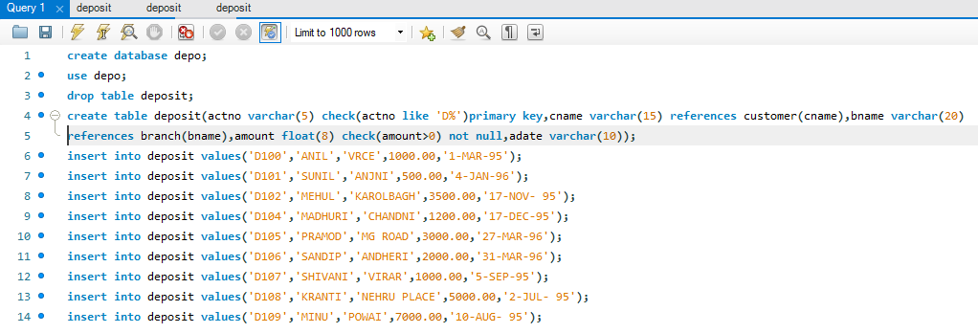

**TABLE 2:**

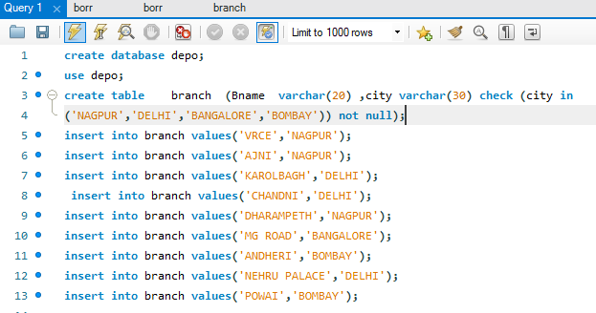

**TABLE 3:**

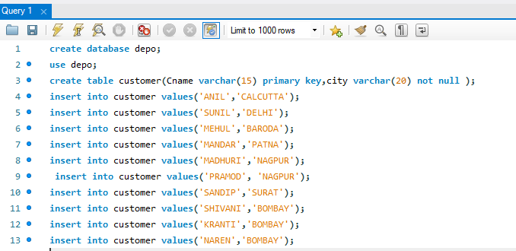

**TABLE 4:**



**OUTPUT SCREENSHOTS:**

**TABLE 1 OUTPUT:**

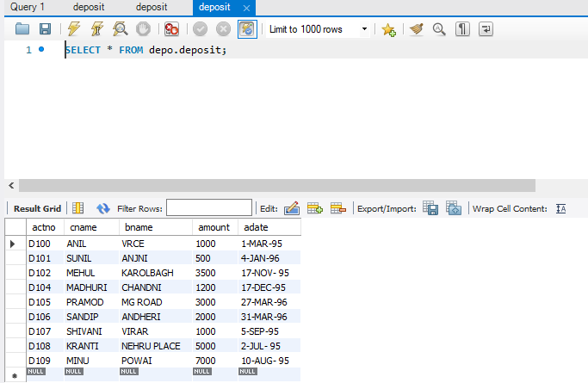

**TABLE 2 OUTPUT:**

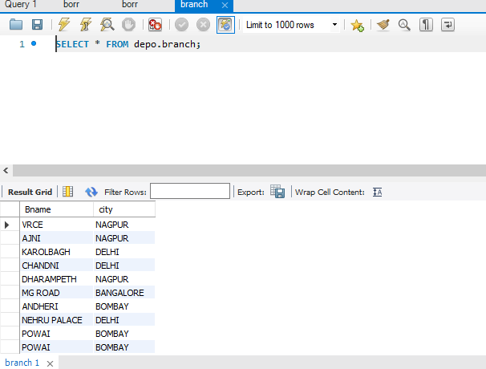

**TABLE 3 OUTPUT:**

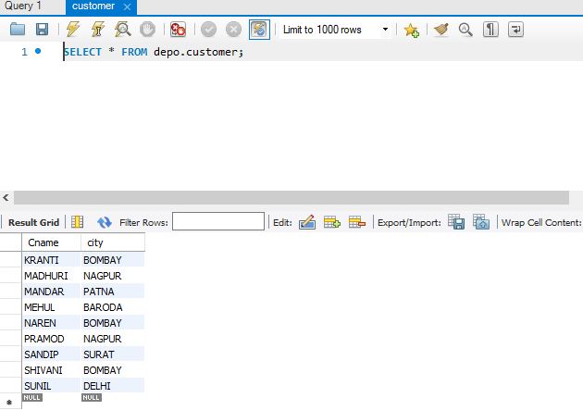

**TABLE 4 OUTPUT:**

